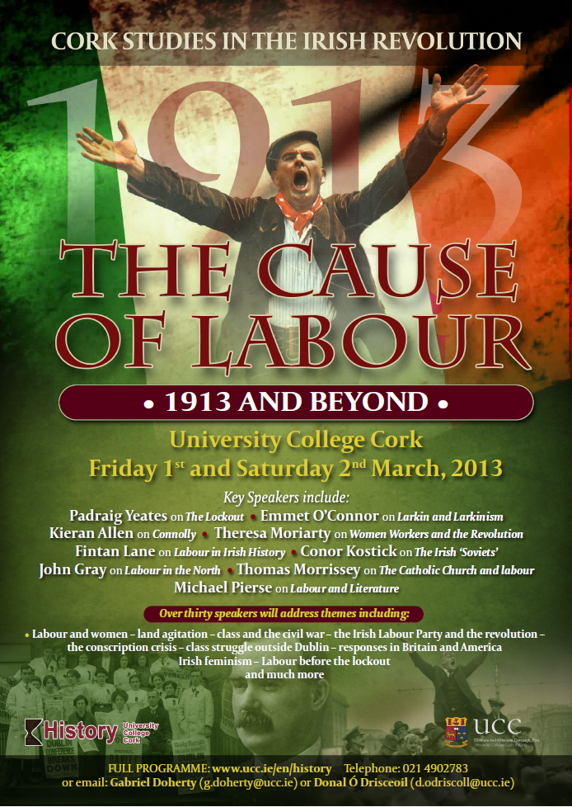

Cork Studies in the Irish Revolution:
The Cause of Labour: 1913 and Beyond

University College Cork
Friday 1st and Saturday 2nd March 2013

Friday 1st | Áras na Laoi G18
8.50am | Opening remarks  Gabriel Doherty, School of History, University College Cork
Session 1: Responses in Britain and Irish-America
Áras na Laoi G18
9.00am | From shamrock to pit prop: industrial unrest, independence, and the Irish embrace of the labour movement in South Wales, 1913-1922  Daryl Leeworthy, Oriel College, Oxford University
9.25am | Scottish responses to the 1913 Lock-out and the 1916 Easter Rising  Chloe Ross, Research Institute of Irish and Scottish Studies, University of Aberdeen
9.50am | ‘The greatest campaign?’ The British Labour party and Ireland in 1921  Ben Bray, Fitzwilliam College, Cambridge University
10.15am | Coffee break
10.40am | ‘Real Irish patriots would scorn the likes of you.’ Larkin and Irish-America  Alan Noonan, School of History, University College Cork
11.05am | Irish American nationalists and the 1913 Dublin Lockout: the diasporic response  David Brundage, University of California
11.30am | break
11.40am  12.05pm  12.30pm | Session 2a: Labour and women Áras na Laoi G18 Session 2b: Labour and the land O’Rahilly Building G38  Revolutions in the everyday: Irish feminism and the reinvention of revolutionary socialism in Ireland, 1912-1923 Liz Kyte, Women’s Studies, University College Cork Fighting over the Kingdom’s sod: the persistence of land agitation in Kerry Richard McElligott, School of History and Archives, University College Dublin  Women workers: from Lockout to Civil War Theresa Moriarty, Irish Labour History Society Practical socialism implemented by non-socialists? Soviets and land seizures in revolutionary Ireland, 1918-23 Olivier Coquelin, Centre for Breton and Celtic Studies, University of Rennes 2  'Growing up poor': Working-class women and family life during the revolution, 1912-23  Sarah-Anne Buckley, School of History,  National University of Ireland, Galway
12.55pm | Lunch break
2.00pm  2.25pm  2.50pm | Session 3a: Labour and the regions Session 3b: Labour and Dublin  Seeing Red: The provincial press reading of the 1913 strike and lockout Peter Hession, Peterhouse college, Cambridge University Socialism from God, in Ireland, and for the Irish: the ‘Irish Worker’ and Dublin working class culture Leah Hunnewell, School of History, Trinity College Dublin  Labour and Clonmel Seán O’Donnell, retired Principal Rockwell College The legacy of the Lockout: lessons from oral history Drs. Mary Muldowney and Ida Milne Directors of the Oral History Network of Ireland  Food preservation and agitation in the regions, 1918 John Borgonovo, School of History, University College Cork The ‘Irish Worker’ and sport in Dublin David Toms, School of History, University College Cork
3.15pm | Coffee break
3.30pm  3.55pm  4.20pm  4.45pm | Session 4a: the Lockout: before & after Session 4b: Must Labour wait?  Labour before the Lockout: Larkinism and progressive trade unionism in the ITUC Adrian Grant, Moore Institute, National University of Ireland, Galway Labour and the 1918 conscription crisis Fiona Devoy-McAuliffe, School of History, University College Cork  Prelude to 1913: the 1909 Cork lockout Luke Dineen, School of History, University College Cork The Labour Party in the Irish Civil War Georgine Althouse, School of History, Trinity College Dublin  Irish railwaymen in peace and war- the changing face of railway industrial relations 1911 -1916 Peter Rigney, Industrial Officer, ICTU How the Dublin Lockout helped teach Irish labour to wait D.R. O’Connor-Lysaght, Irish Labour History Society  From the Lock-out to World War Two: British socialists and communists facing the Irish revolutionary decade  Adrià Llacuna, Universitat Autonoma de Barcelona
5.15pm | Dinner break

Friday 1st | Official conference Opening and launch of University College Cork multitext project on the lockout  Boole IV Lecture Theatre
7.15pm | The cause of Labour: 1913 and beyond  Padraig Yeates, 1913 Committee

Saturday 2nd | Boole II Lecture Theatre
9.15am | The Lord and Labour: clerical responses to the workers’ question  Paul Maguire, School of History, Dublin City University
9.40am | Archbishop Walsh, the Dublin diocese and the 1913 Lockout  Thomas J. Morrissey, SJ
10.30am | Coffee break
10.45am | The labour plays of Andrew Patrick Wilson, 1912-14  James Curry, Department of History, National University of Ireland, Galway
11.10pm | Labour in Irish literature  Michael Pierse, Research Fellow, Institute for Collaborative Research in the Humanities, Queen’s University Belfast
12.00pm | Break
12.05pm | The ‘Decade of Centenaries’ – a catastrophe for northern labour  John Gray, Independent social historian
1.00pm | Lunch Break
2.10pm | James Connolly and the cause of labour  Kieran Allen, School of Sociology, University College Dublin
3.00pm | Labour in Irish history: James Connolly and Irish historiography  Fintan Lane, Independent scholar
3.50pm | Coffee break
4.05pm | The Soviets in Ireland  Conor Kostick, School of Histories and Humanities, Trinity College Dublin
4.55pm | Break
5.00pm | Larkin & Larkinism  Emmet O’Connor, School of English and History, University of Ulster
6.00pm | Closing remarks  Donal Ó Drisceoil, School of History, University College Cork

Conference organised by the School of History University College Cork, with assistance from the Research Fund, School of History, University College Cork.
For further information please telephone 021-4902783, email g.doherty@ucc.ie, or 021 4903048, D.ODriscoll@ucc.ie.
Please address any correspondence to: ‘1913/Labour conference’, School of History, University College Cork.
Conference web site http://www.ucc.ie/en/history/labourconference.html
Organisers: Gabriel Doherty, Donal Ó Drisceoil, School of History, University College Cork.

The conference is dedicated to the memory of the prominent trade union activist and pioneer of labour history in Ireland, Donal Nevin.

